Summer Menu  2018  Week 1 | Monday | Tuesday | Wednesday | Thursday | Friday
 | Sausage Peas Mash with Gravy (Optional)  Vegetarian option | Tacos with a variety of fillings | Chicken Nuggets and salad  Vegetarian option | Beef Lasagne  Vegetarian Option | Wraps with Chicken, ham, cheese and salad
Week 2 | Vegetarian  Spaghetti Carbonara | Variety of Sandwiches | Fish Fingers peas and chips | Vegetarian Spaghetti Bolognaise | Beans on Toast  (Cheese optional)  Cucumber Sticks
Fruit bowl available everyday  Water and Milk available everyday | 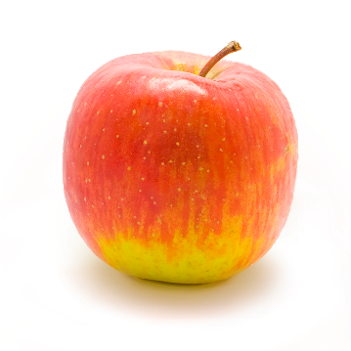 | 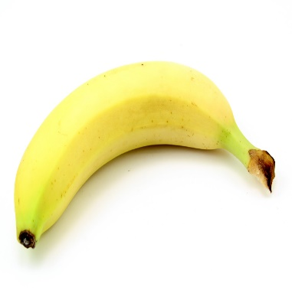 |  |  | 