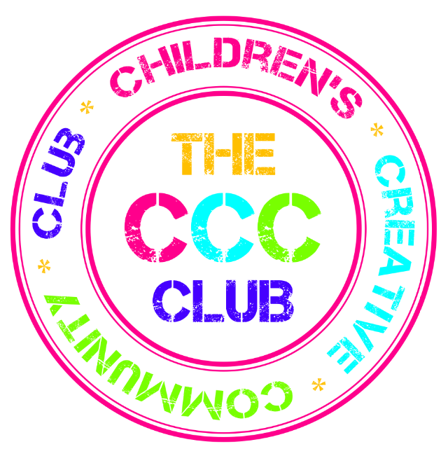 CCC Club Application Form

Any information you provide on this form will be held securely and in confidence.

Child’s Details

First Name:

Surname:

What they like to be called:

Date of Birth and Age on 1st requested day at The CCC Club:
School they attend:

First Language:

Any other languages spoken: (include sign-languages)

Are you applying for places for any additional children?
Yes / No (delete as appropriate)

If Yes, please write their name(s) below and fill in separate application form for each child

Name

Name

Does the child receive or will be expected to receive free schools meals?
Yes / No (delete as appropriate)

Parents/Guardian/Carer Details

Person 1
Relationship to child:
Title:
First Name:
Surname:
Home Address:
Work Address:
Daytime Telephone:
Evening telephone:
Mobile telephone:
Email address:

Person 2
Relationship to child:
Title:
First Name:
Surname:
Home Address:
Work Address:
Daytime Telephone:
Evening telephone:
Mobile telephone:
Email address:

Alternative Emergency Contact Details (please provide the details of at least one person we can contact if we are not able to get hold of you)

Person 1
Relationship to child:
Name:
Home Address:
Work Address:
Daytime Telephone:
Evening telephone:
Mobile telephone:
Email address:

Person 2
Relationship to child:
Name:
Home Address:
Work Address:
Daytime Telephone:
Evening telephone:
Mobile telephone:
Email address:

Details of Child’s Doctor

Name of Doctor:

Address: | Telephone:
About your Child

Please detail any additional/special needs your child has: (please provide full details)

Please detail any medical needs your child has: (please provide full details, if medication is needed an additional medication form will need to be completed)

Please detail any allergies your child has: (please provide full details)

Please detail any dietary requirements for your child: (please provide full details)

What are your child’s favourite activities?

Is there anything your child doesn’t like (particular foods, games etc) or is scared of?

Any additional information:

Off-site activities

We may take CCCClub kids on local outings. Do you give permission for your child to participate in such activities? Yes / No

Please note we assume that you give permission for your child to visit the Telegraph Hill parks and do not count these as outings.

Consent

I consent for my child to attend The Children’s Creative Community Club; I understand that the club has policies and procedures and that there are expectations and obligations relating to both the club and myself and my child and agree to abide by them.

I give permission for a trained member of staff to administer appropriate first aid if required.

I give permission for The Children’s Creative Community Club to seek any necessary emergency medical advice or treatment in the event that my child is involved in a serious accident. I expect to be contacted immediately on the above telephone numbers.

Late collection of my child may result in a charge of £5 for every 10 minutes after 6.30pm. I understand that persistent late or non-payment of fees may jeopardise my child’s continued place. In an emergency I will ring the club.

I confirm that the information given on all forms is correct and agree to notify the club staff of any changes in detail.

I understand that all the club’s policies will apply to The Children’s Creative Community Club, including Child Protection and Data Protection.

I understand that the information given on this registration form is confidential.

I have read and accepted the above conditions for my child attending The Children’s Creative Community Club

Signature of Parent/Carer/Guardian: ______________________

Date: __________

PLEASE TYPE YOUR NAME ABOVE - YOU CAN SIGN A PAPER COPY LATER IN THE APPLICATION PROCESS

DAYS / SESSIONS REQUESTED

Please indicate which days / sessions you would like your child to attend The CCC Club. Unfortunately we cannot guarantee that you will be allocated the days that you request.

Your Preferred Start  Date at The CCC Club  (please tick box) | ASAP ☐  1st September 2014 ☐  Other (please specify) ☐ _____________

Breakfast Club | Mon | Tue | Wed | Thu | Fri
(Please tick the sessions that you would like your child to attend)
Afterschool Club | Mon | Tue | Wed | Thu | Fri
(Please tick the sessions that you would like your child to attend)

Please provide any additional information about the sessions requested, such as whether you can be flexible about which days you require. This will help us schedule the children to places as fairly and as inclusively as possible:

